VocalSharp Editor Manual
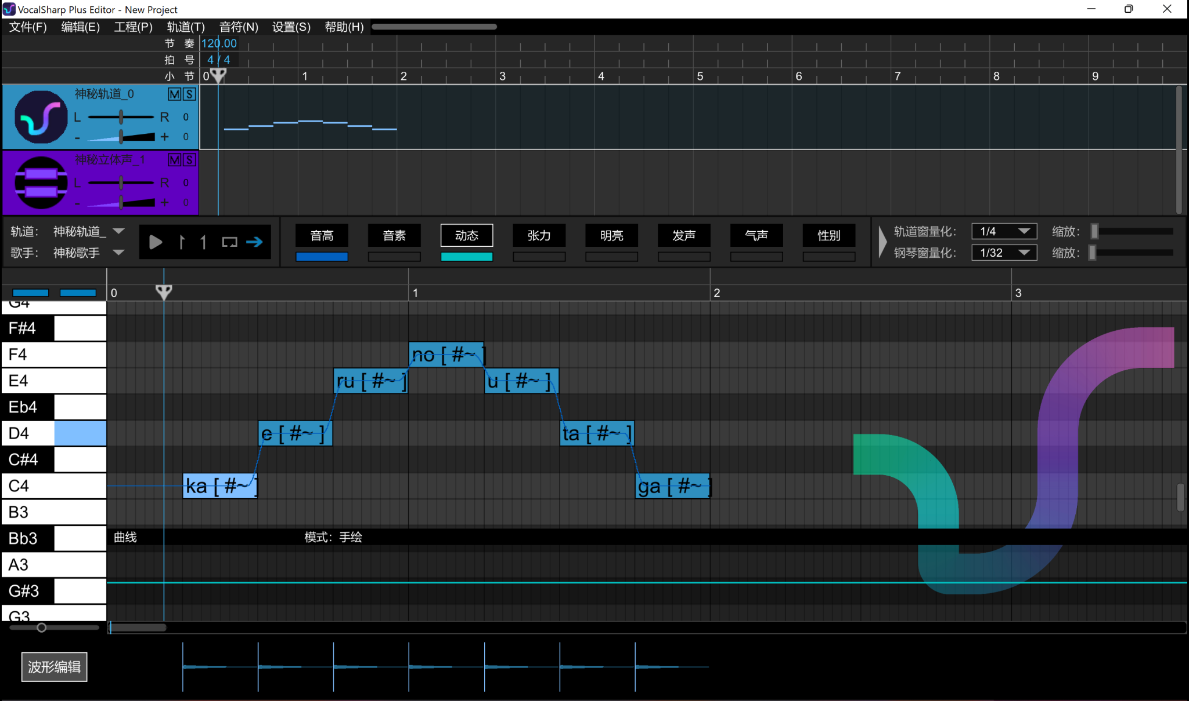

So…. You got the shiny new open synth, right? Well… it's in Chinese… and we don’t know any Chinese… So what do we do? I’ll explain it to you!
Let's start from the top to the bottom.

Table of Contents
Top bar 4
File (文件) 4
Edit (编辑) 5
Project (工程) 5
Tracks (轨道) 6
1. Add track (新建轨道) 6
2. Select all tracks (全选) 6
3. Change project pitch (整体变调) 6
Note (音符) 7
Settings (设置) 7
Shortcuts (操作): 7
Themes (视图) 8
Help (帮助) (Unavailable) 8
Track Manager 9
Track Controls 9
Control Strip/Operation Area 10
Track Settings 10
Playback 10
Quantization Tool and Zoom 11
Parameters 12
Controls 12
Pitch(音高) 14
Phoneme (音素) 15
Dynamics (动态) 16
Tension (张力) 17
Brightness (明亮) 17
Voicing (发声) 18
Breathiness (气声) 19
Gender (性别) 19
Timing (曲线) 20
Growl (怒音) 21
Piano Roll 22
Miscellaneous 23

Top bar

File (文件)
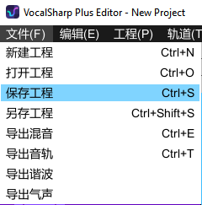
The first option houses all your project file commands. What they do is;
- New project file (新建工程) (Ctrl+N)
- Open project file (打开工程) (Ctrl+O)
- Save project file (保存工程) (Ctrl+S)
- Save project file as (另存工程) (Ctrl+Shift+S)
- Export all tracks to one wav (导出混音) (Ctrl+E)
- Export current track (导出音轨) (Ctrl+T)
- Export Harmonic Frequency (导出谐波)
- Export Breathiness (导出气声)

Edit (编辑)
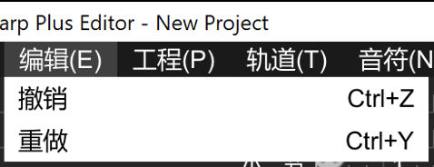
The second option is for editing commands. They are;
- Undo (撤销) (Ctrl+Z)
- Redo (重做) (Ctrl+Y)

Project (工程)
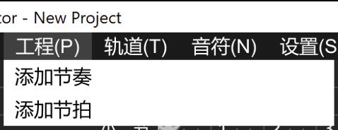
The third option is for editing timings, these are;
- Add BPM/Tempo change (添加节奏)
- Add Time Signature change (添加节拍)
Changes will be added where the play head is located.

Tracks (轨道)
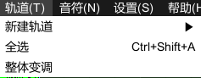
The above show three options, the first is a drop-down menu, the second selects all the tracks while the third will open a new window.

1. Add track (新建轨道)
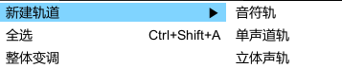
- Create Note track (音符轨)
- Create Mono audio track (单音道轨)
- Create Stereo audio track (立体声轨)

2. Select all tracks (全选)
It selects all tracks inside the editor.

3. Change project pitch (整体变调)
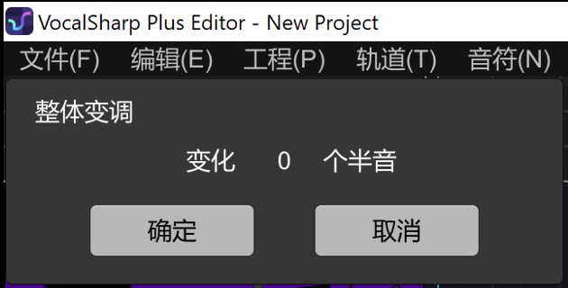
This is a feature that transposes (变化) the whole track, based on semitones(半音).
You can change the number by holding left click and dragging left or right.
The buttons are;
- Okay (确定)
- Cancel (取消)

Note (音符)
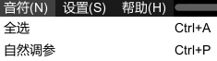
1. Select all notes (全选) (Ctrl + A)
2. Automatic Modulation (自然调参) (Ctrl + P)

Settings (设置)
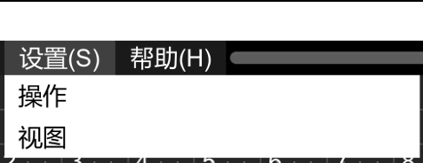
These are the Settings tab. Selecting the options will open a new window.

Shortcuts (操作):
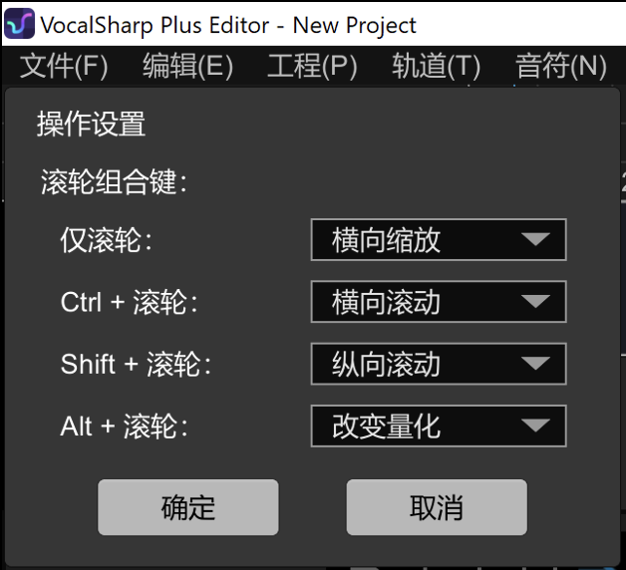
With these you can change what the shortcut keys do. 仅滚轮 means “mouse wheel only”, and 滚轮 means “mouse wheel”. The left shows all available shortcuts VocalSharp uses.
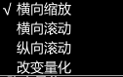
Above is the option box. They mean;
- Zoom in/out (横向缩放)
- Scroll left/right (横向滚动)
- Scroll up/down (纵向滚动)
- Change track quantization (改变重量)

Themes (视图)
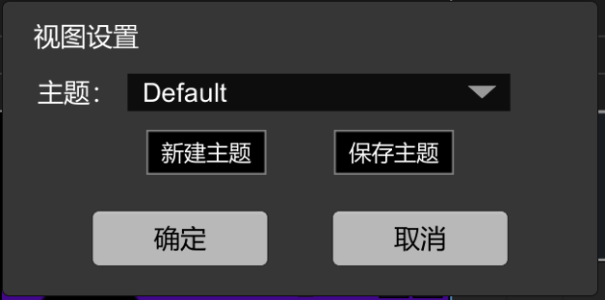
With this feature, you can change VocalSharp’s color scheme! I wouldn’t recommend messing with this.

Help (帮助) (Unavailable)
This is a work in progress feature. It shares the same option as “Note” :3

Track Manager
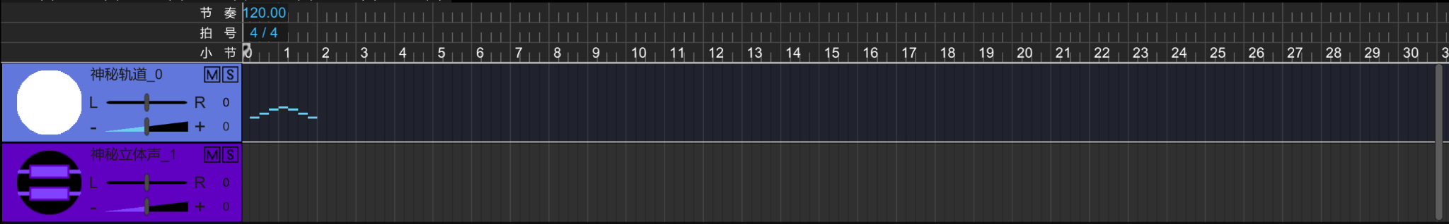
Mouse controls can be used here.

Here you scroll to move sideways. Your time measurements (and custom ones made in the “Project(工程)” tab) will appear here. Double-click on the measurements to change its values.

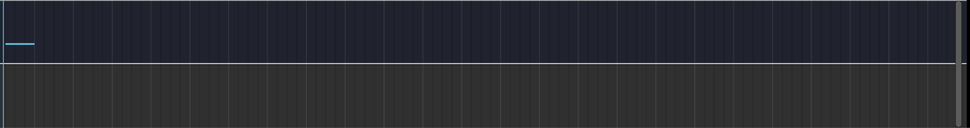
Here you scroll to zoom. Double click on any track to switch to the selected track quickly.

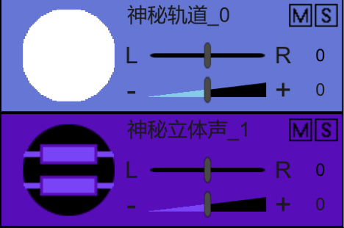
And here you scroll to move up and down

Click whenever in the measurements row to move the playback line there.

Track Controls
Double click on the track name to edit it. Default name is 神秘轨道_0

The M button means Mute, and the S button means Solo/Isolate (it will make so that only the tracks with the S button selected play sound).

The L to R bar defines the alignment in stereo sound, if you put it towards L, the track will sound more on the left speaker, and vice-versa.
The - to + bar is a volume bar.

Control Strip/Operation Area
We’re getting onto the good stuff! But first, let’s look at it.

Kinda scary right? You can call this the Control Strip. The Chinese manual calls it the Operation Area.

Track Settings

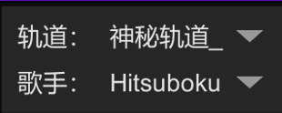

With these two options, you can control what track (轨道) you see, and which singer (歌手) sings in it.
轨道 changes your track, and 歌手 changes your singer.

Playback

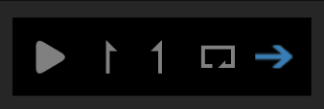

These are simple;
- Play: Start track playback.
- Segment Tool: If you want to play only part of your track, you can use these, drag them from the edge of the first measure to where you want to play.
- Loop: Loop audio, can be used with the Segment Tool
- Automatic Piano Scrolling: With this feature, when you’re playing your file, it will make the piano roll scroll along to the playback head. Disable it to make the piano roll view stay put when in playback.

Quantization Tool and Zoom
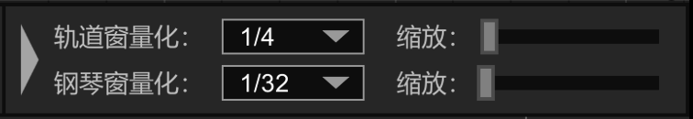
Before we look at the parameters, let’s look at this. This is a handy tool to snap notes to the grid! (Tip: by pressing Alt, you can ignore quantization snap!)
Can be dragged up and down to change the size of the track and piano roll ratio.

The first one changes the playback line on the Measurements row snap. This is 1/4,and this is 1/34.

The second one changes the quantization snap in the piano roll. This is 1/34.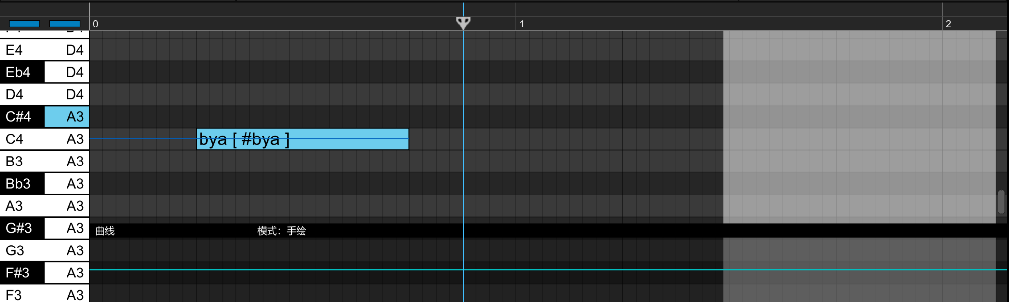
And this is 1/128.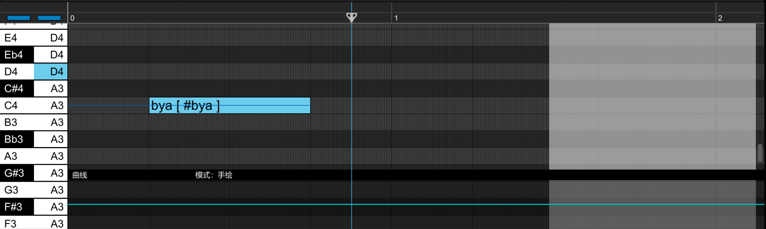

The bars on the side changes the zoom (缩放), in the same order than the snap (top is for track bar, bottom is for piano roll). The triangle on the right hides the panel away.

Parameters
Let’s get onto the good stuff! These are the VocalSharp parameters. First, let’s start by viewing the…

Controls
To select a parameter, press the labeled button. The button will have a white border when in view.
To hide a parameter from view, press the colored button below the labeled button. The color will disappear when the parameter is not in view.

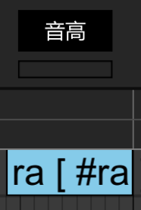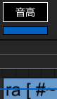

You can also change the default value of a parameter by editing its value on the top of the Parameter Bar located at 默认值. You can also drag the top of the Parameter Bar to change its height.
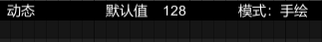

By default, adjusting parameters will be done in Pencil mode (模式：手绘) which allows you to freely adjust your parameters.
You can change this to Anchor mode (模式：锚点) by clicking on 模式, which will activate Cubic Spline calculations to adjust your parameters.
Holding right-click and drag will restore parameters to the default value.
This may have bugs/issues during usage since it is not properly listed in the Chinese manual, so be careful.
(Above image is a gif. Please adjust document settings if it is not playing.)

Hold right-click and drag for box selection in the piano roll, and hold down shift for a more accurate box.
To copy parameters, use Shift+C to copy and Shift+V to paste.
Ctrl+Shift+C is used to copy both notes and parameters. Make sure to select your notes right at the start of them, or else the parameters won’t be aligned.

Now, let’s go onto the parameters, in order.

Pitch(音高)
This works like the pitch parameter in DeepVocal, and you edit it in the piano roll.
From a boring old note,

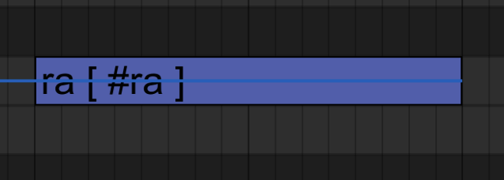

To a note with a special attack and release!

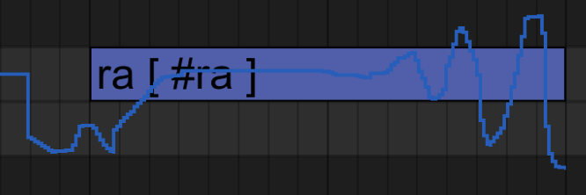

Phoneme (音素)
This parameter is edited in the parameter bar. It allows you to change the pitch group of the note parts.

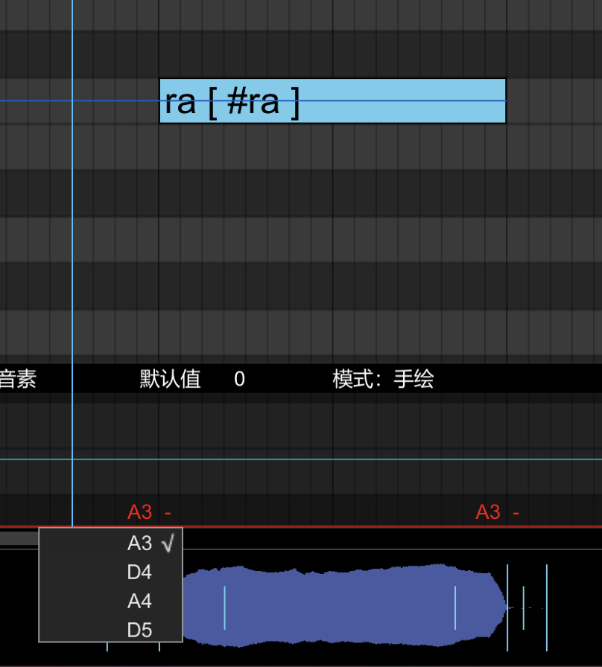

As you can see, this singer (Hitsuboku) has 4 pitches, and the note has two parts, the [ra] syllable and the [a -].
You can select the note to change the pitch. (The cyan line is the dynamics parameter in the background which can be turned off in accordance with the “Controls” part of this section above).

Dynamics (动态)
This parameter edits the volume. It is edited in the parameter bar. Range: -12dB ~ +12dB, set 0 to mute.

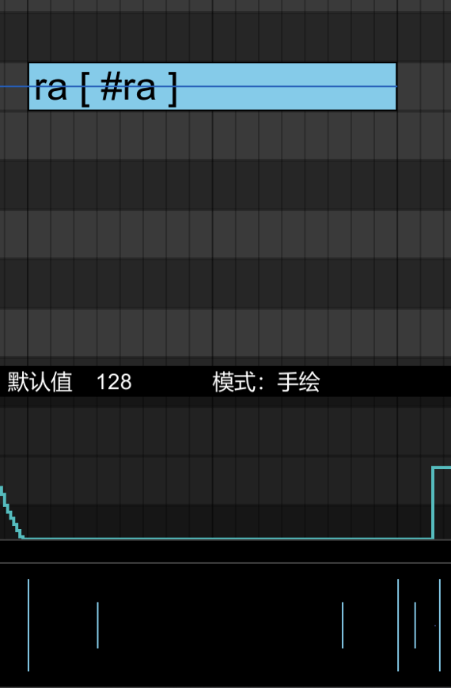
No noise…

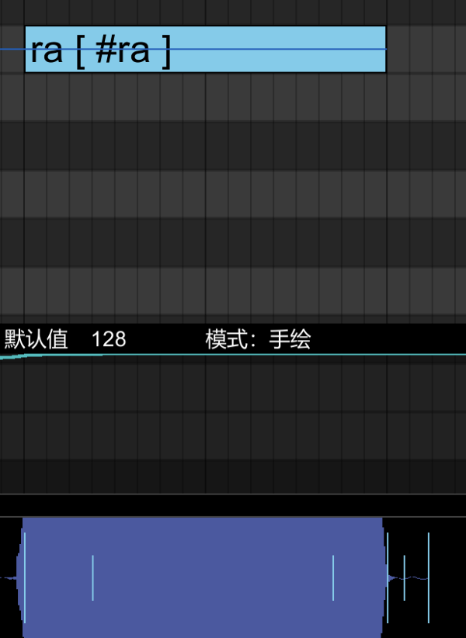
Too much noise!

Tension (张力)
This parameter works exactly like how Tension works in Synthesizer V. Go up for a tense voice, and down for a soft one.
It’s edited in the parameter bar. Simulates singing intensity.

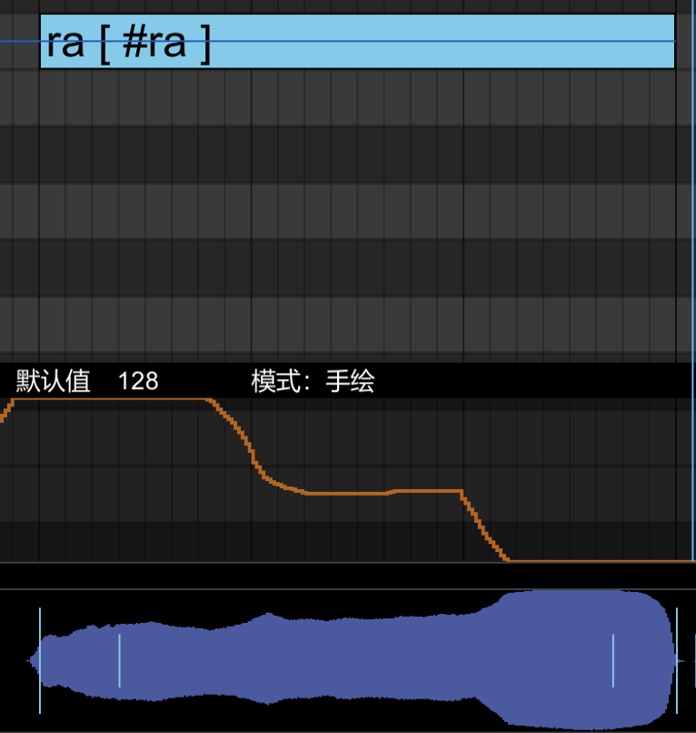

Brightness (明亮)
This is just like VOCALOID’s brightness parameter, and it works the same. Mixing this with the Tension parameter you can make a voice sound mellow yet tense!
It’s edited in the parameter bar.

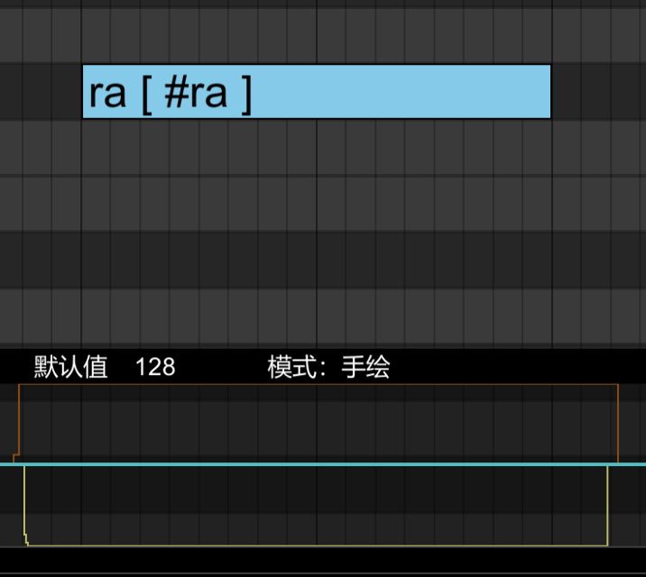

Voicing (发声)
This works exactly like the Voicing parameter in Synthesizer V. To quote from the aforementioned manual, “Voicing is the interpolation between normal phonation and whispering.”
It’s edited in the parameter bar. This simulates the degree of vocal vibration and adjusts the proportion of harmonic components. Set 0 to whisper.

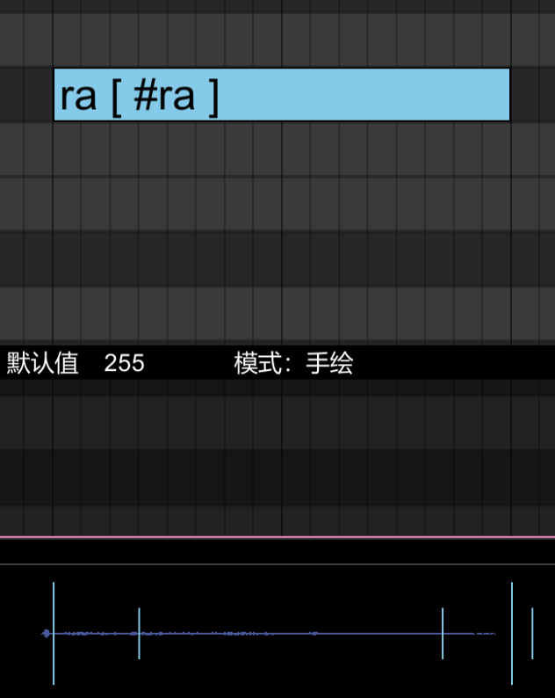
Hush hush!

Breathiness (气声)
This is your standard Breathiness parameter from any vocal synthesizer. Turn it up for a super airy voice, and down for a solid one. Also known as “Breathiness”.
It’s edited in the parameter bar. This simulates breath in vocals. It adjusts the proportion of noise components. Ranges from -12dbB ~ +12dB

Gender (性别)
And like Breathiness, this is another bog-standard Gender parameter.
This creates an approximation of male and female vocals from an existing voicebank. Specifically, it adjusts the resonance peak offset. Draw up for male and lower for female.

Timing (曲线)
Also known as the phoneme area. Allows for time remapping. Vertical axis represents before adjustment, horizontal axis represents after adjustment. Any changes made to the note will reset the curve parameters of itself and the adjacent notes, so it must be adjusted after the note is established. The anchor points can be dragged.

The waveform area is more intuitive however, located at the bottom of the piano roll.

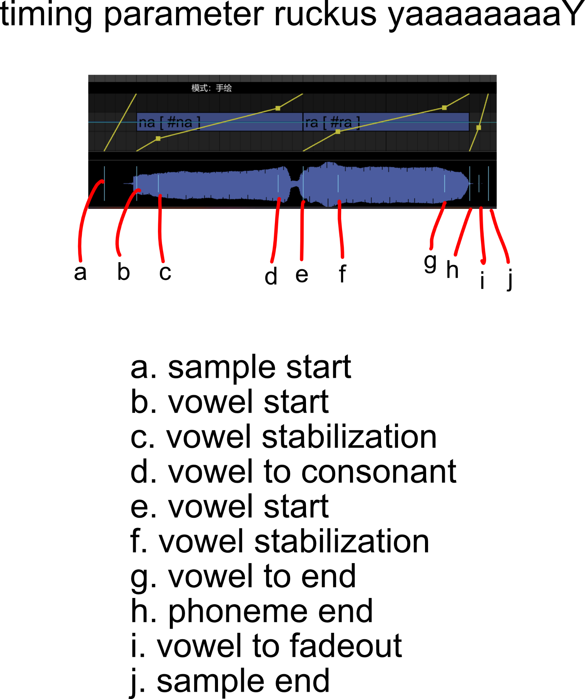

Growl (怒音)
And last, but not least, the Growl parameter! It’s very simple, if you put it at the top, you get an artificial death growl, and by default it’s at 0. It’s edited in the parameter bar.

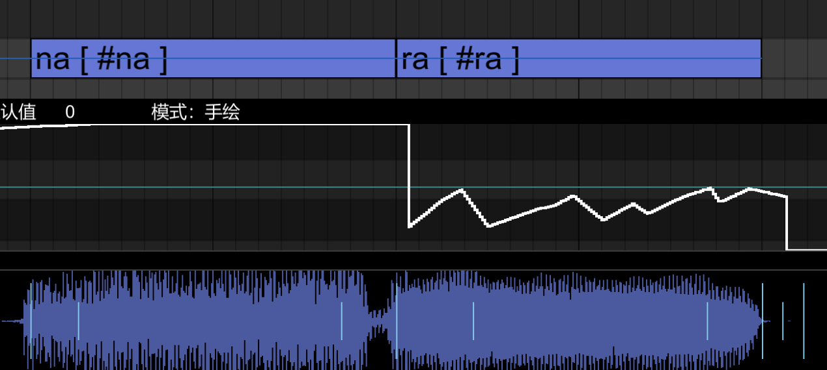

Piano Roll
Let’s get onto the main part! This is the Piano Roll, standard for most singing synthesizers.

First, left click and drag to make a note.
You can double click it to edit its lyrics. (Tip: To write phonemes instead of relying on the dictionary, there is a function to type phonetics directly, it just has to be according to your voicebank’s specific phonetic alphabet/encoding (ex. #a, J#M, k w#a, jh#ao, etc.))

Right click on a note to bring out the context menu.
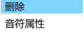
- first option is Delete (删除)
- second option is Note Properties(音符属性)
By default, the Delete option is highlighted for you when you right click, so you can double right click to delete notes quickly.

Using the note properties pane, you can add vibrato.
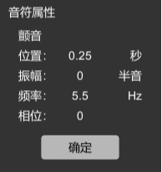
You can adjust the vibrato settings in the window that appears. The meanings are:
- Position (位置) (drag left to increase vibrato length)
- Amplitude (振幅) (drag right to increase vibrato size)
- Frequncy (频率) (drag right to increase vibrato frequency)
- Phase (相位) (drag left/right to change phase)
The button means confirm (确定)
Sometimes the vibrato function doesn’t work. You may need to refresh the option for it to appear.

Right button and drag for box selection, hold down shift for a more accurate box.
Hold down the middle mouse button scroll wheel slider to scroll horizontally and vertically at the same time.
Drag the ends of the note to edit its length.

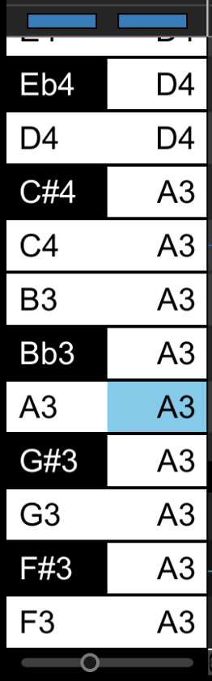
Miscellaneous
The piano roll has some nifty features! In it, you can look notes up, and which pitch group it’s associated with. To turn off these reminders, you can press the first blue button at the top for the notes, and the second for the pitch groups.

The slider at the bottom changes note width, so if you wanna see fatter notes, slide it to the right, and vice versa.

That should be all! Thanks for reading!

If I missed something, we can chat in the VocalSharp channel in the Vocalo Helpdesk server! If you don’t have access to it, message subpum on Discord (subpum#8774) or Twitter (@suburbanpuma).

Alternatively, you can contact Nielon_Saberton in the Official VocalSharp Discord for assistance.

Translated and Localized by: Nielon_Saberton & subpum
Thanks to Nielon_Saberton for the update! (V3 13/2/21)

